Town of Richmond Residents
Pickup will continue every Monday and residents will now be provided with (1) 95 gallon recycle tote.
Totes need to be curbside no later than 5:30 am on scheduled pickup day to guarantee pickup.
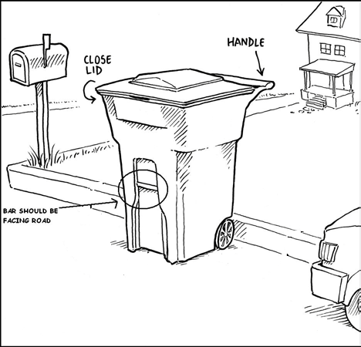
- Please place tote as indicated in the picture, with the bar and lid opening street side. The collection system will require that the provided cart is mechanically picked up and then tipped into the truck. Residents are required to use provided carts for their household trash and recycle.
- Each household is allowed (1) tote of trash and recycle every week.
- Place your cart to maintain a (3) foot separation from obstructions, including other carts, mailboxes, parked cars, trees and snow banks
- These totes are the property of Harter’s, for tote repair or rental of additional totes; please call (715) 253-2619 or (888)804-8556. In the event you relocate, these carts are to stay with the property.

Town of Richmond Residents
Pickup will continue every Monday and residents will now be provided with (1) 95 gallon recycle tote.
Totes need to be curbside no later than 5:30 am on scheduled pickup day to guarantee pickup.
- Please place tote as indicated in the picture, with the bar and lid opening street side. The collection system will require that the provided cart is mechanically picked up and then tipped into the truck. Residents are required to use provided carts for their household trash and recycle.
- Each household is allowed (1) tote of trash and recycle every week.
- Place your cart to maintain a (3) foot separation from obstructions, including other carts, mailboxes, parked cars, trees and snow banks
These totes are the property of Harter’s, for tote repair or rental of additional totes; please call (715) 253-2619 or (888)804-8556. In the event you relocate, these carts are to stay with the property.

